Date -

Experiment – 3
Client Side Scripting

Program – 1

AIM :
Create a Web page HTML CSS that holds a bulleted list of the names of your friends. Make sure that the bullets are in plain circle.

PROGRAM :

prog1.html

<!DOCTYPE html>
<html>
<head>
<title>List</title>
<link rel="stylesheet" href="prog1.css">
</head>
<body class = "body">
Friends List
<ul type = "circle">
<li>Sid</li>
<li>Manas</li>
<li>Srini</li>
<li>Safi</li>
<li>John</li>
</ul>
</body>
</html>

prog1.css

.body {
align-self: auto;
background: palegreen;
}

OUTPUT :

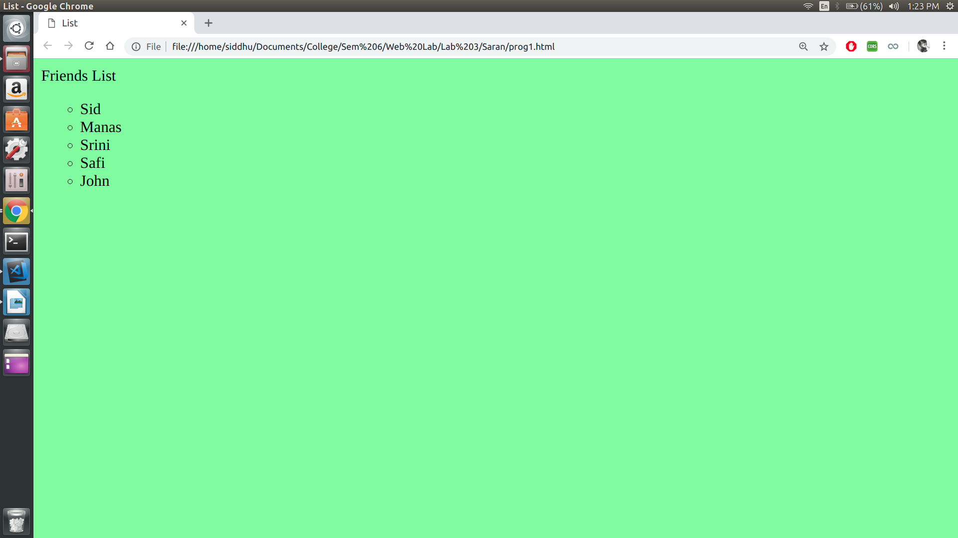

Result:
Thus the program is executed and output is obtained

Program – 2

AIM :
Create a web page in HTML CSS to display the maximum and minimum temperature of 5 cities using table.

PROGRAM :

prog2.html

<!DOCTYPE html>
<html>
<head>
<meta charset="utf-8" />
<meta http-equiv="X-UA-Compatible" content="IE=edge">
<title>Table</title>
<meta name="viewport" content="width=device-width, initial-scale=1">
<link rel="stylesheet" type="text/css" media="screen" href="prog2.css" />
</head>
<body>
<table class = "table">
<tr>
<th>City</th>
<th>Max Temperature</th>
<th>Min Temperature</th>
</tr>

<tr>
<td>Chennai</td>
<td>45</td>
<td>26</td>
</tr>
<tr>
<td>Kharagpur</td>
<td>35</td>
<td>15</td>
</tr>
<tr>
<td>Peshawar</td>
<td>10</td>
<td>-10</td>
</tr>
</table>
</body>
</html>

prog2.css

.table {
background-color: paleturquoise;
border: 1px solid green;
}

OUTPUT :

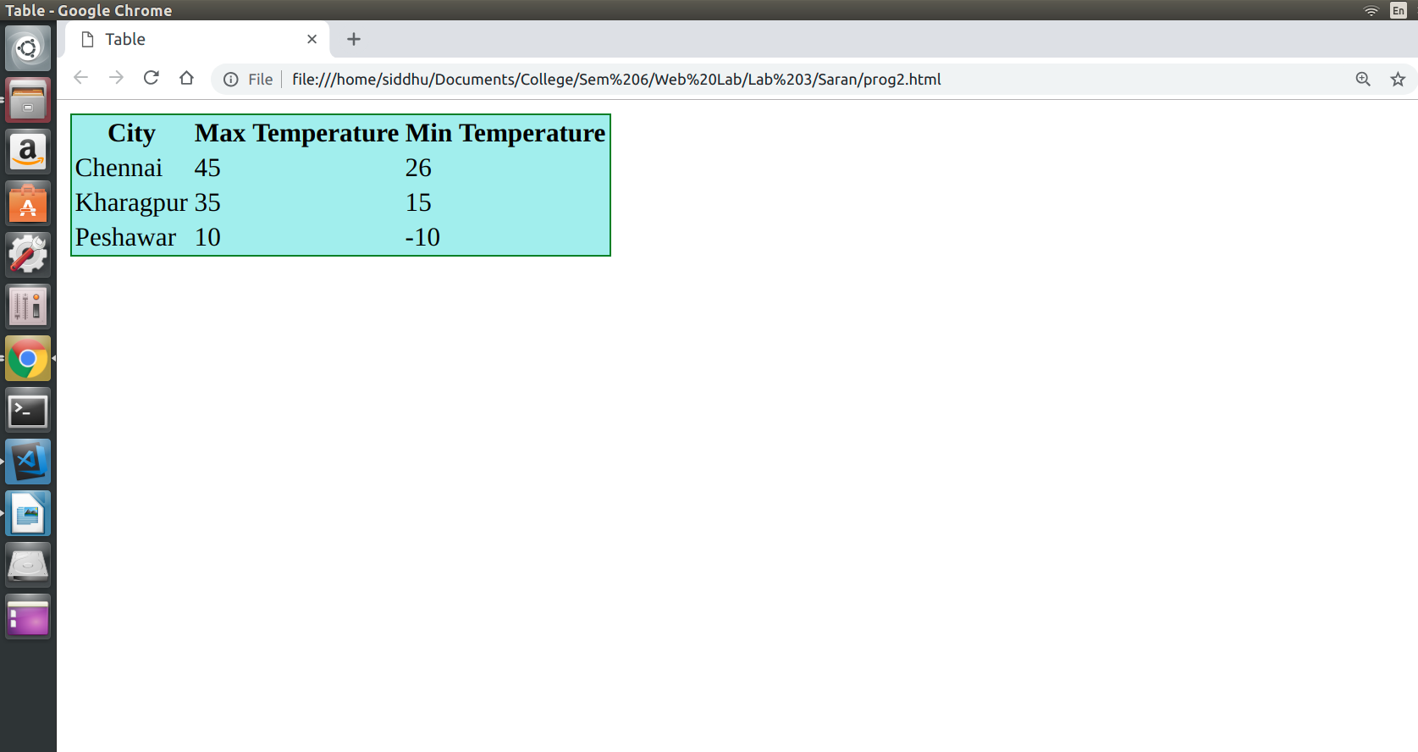

Result:
Thus the program is executed and output is obtained

Program – 3

AIM :
To design a web page in HTML that accepts username and password. Opens a new window when the password corresponds to a particular value is set by the developer.

PROGRAM :

prog3.html

<!DOCTYPE html>
<html lang="en">
<head>
<meta charset="UTF-8">
<meta name="viewport" content="width=device-width, initial-scale=1.0">
<meta http-equiv="X-UA-Compatible" content="ie=edge">
<title>Document</title>
<!-- <link rel="stylesheet" href="prog3.css"> -->
</head>
<body>
Username:<input type="text", required, id="inp1">
Password:<input type="password", required, id="inp2">
<button type="button", onclick="check()">Submit</button>
</body>
<script>
function check()
{
var uname = document.getElementById("inp1");
var pass = document.getElementById("inp2");
var k = pass.value;
if( k === "password")
{
window.open("https://www.google.com/")
}
}
</script>
</html>

OUTPUT :

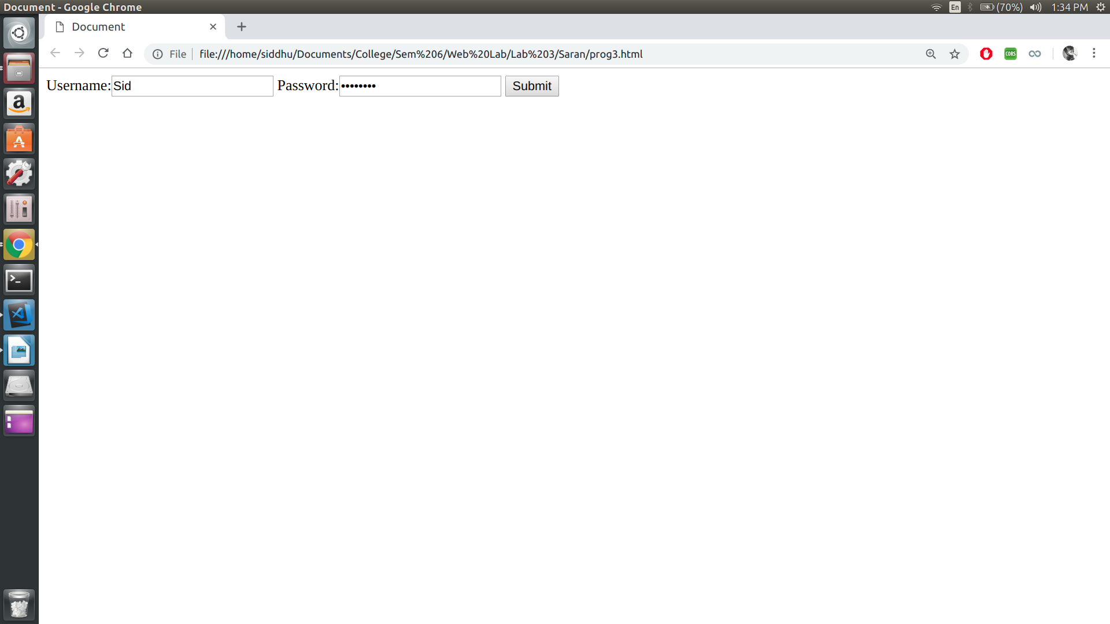

Result:
Thus the program is executed and output is obtained

Program – 4

AIM :
To design a web page in HTML that consists of 2 text boxes. When the page is forst loaded set the focus to the first text box. The user should not be allowed to leave the box unless enters a value in it.

PROGRAM :

prog4.html

<!DOCTYPE html>
<html lang="en">
<head>
<meta charset="UTF-8">
<meta name="viewport" content="width=device-width, initial-scale=1.0">
<meta http-equiv="X-UA-Compatible" content="ie=edge">
<title>Document</title>
</head>

<body>
Name: <input type="text" , id="ip1" , onblur="check()" , autofocus>
Password: <input type="password" , id="ip2">
<button onclick="submitFunc()">Submit</button>
</body>
<script>
function check() {
var box = document.getElementById("ip1").value;
if (box == "")
document.getElementById("ip1").focus();
}
function submitFunc(){
alert("Password is : " + document.getElementById("ip2").value);
}
</script>
</html>

OUTPUT :

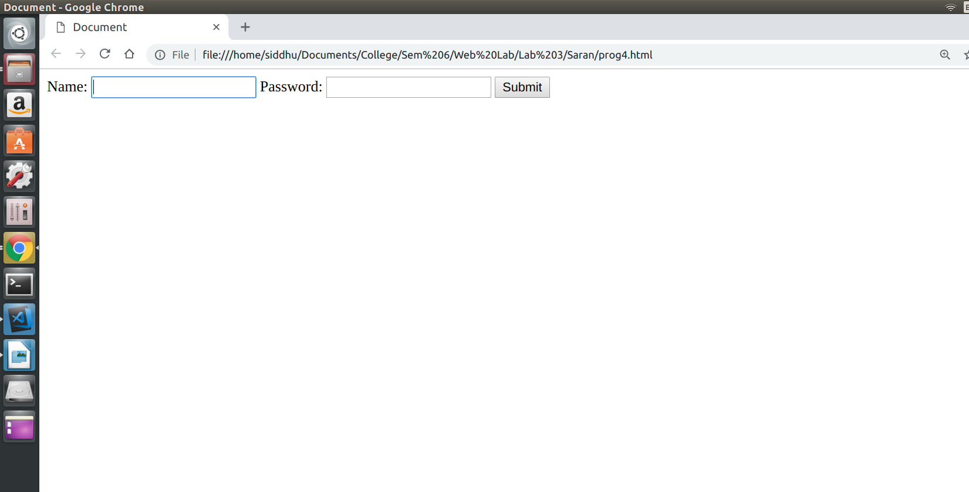
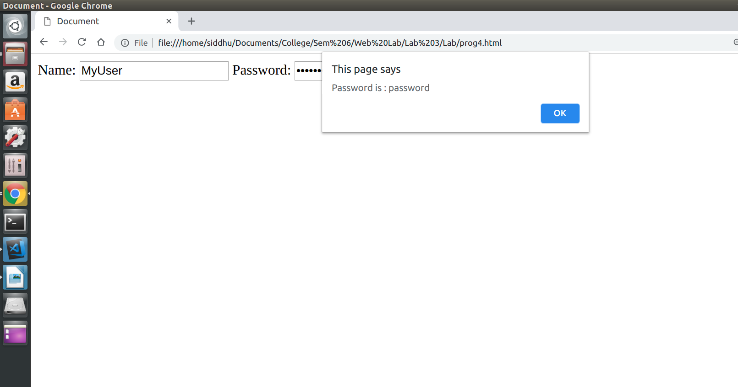

Result:
Thus the program is executed and output is obtained

Program – 5

AIM :
To display an alert box to alert the x and y co-ordinates of the cursor in JavaScript.

PROGRAM :
prog5.html

<!DOCTYPE html>
<html lang="en">
<head>
<meta charset="UTF-8">
<meta name="viewport" content="width=device-width, initial-scale=1.0">
<meta http-equiv="X-UA-Compatible" content="ie=edge">
<title>Document</title>
</head>
<body onclick="fetchCoordinates()", class="body">
<p class = "para" >Click Me!!</p>
</body>
<style>
.body{
width: 100%;
min-height: 100%;
background-color: aqua;
}
</style>
<script>
function fetchCoordinates() {
console.log("heloo");
var cX = event.clientX;
var cY = event.clientY;
alert("xCoordinates: " + cX + "yCoordinates: " + cY)
}
</script>
</html>

OUTPUT :

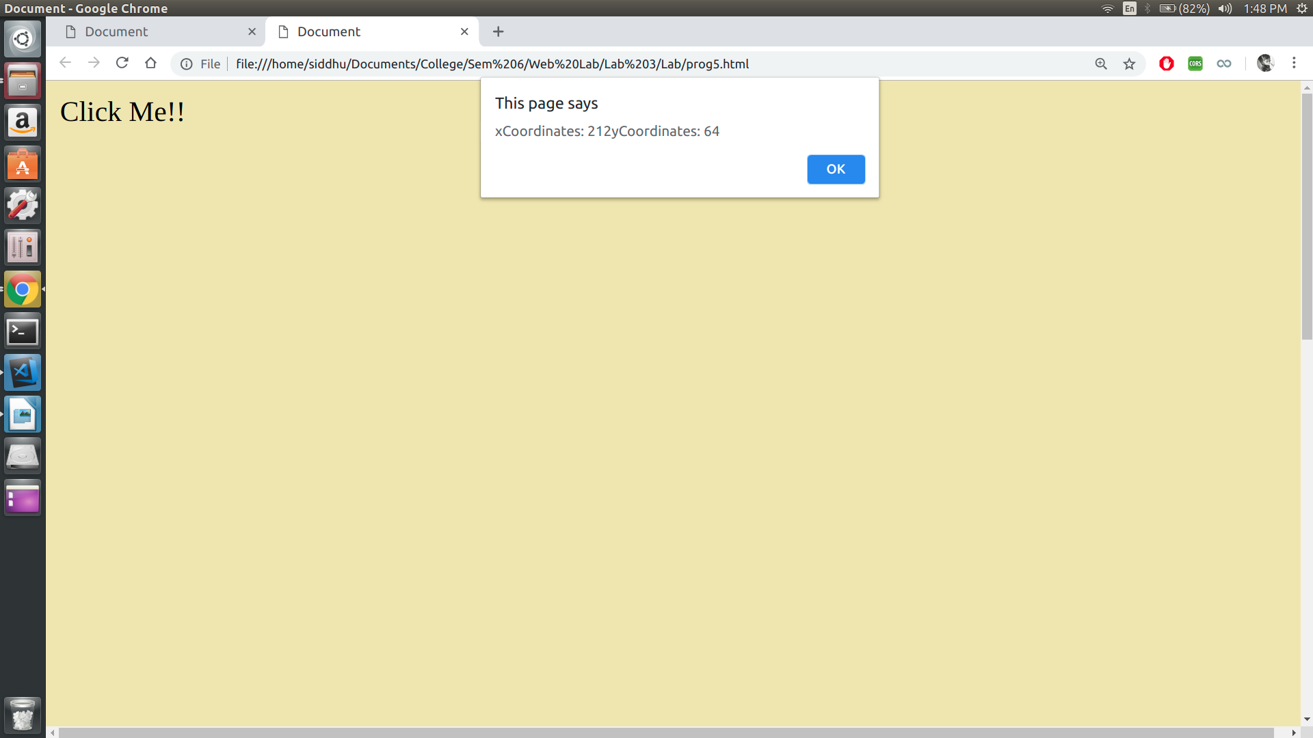

Result:
Thus the program is executed and output is obtained
Program – 6

AIM :
To design a simple arithmetic calculator in JavaScript.

PROGRAM :

prog6.html

<html>
<head>
<title>Calculator</title>
</head>
<body>
<h3>Simple Calculator</h3>
<br />
<style>
#calc {
width: 300px;
height: 250px;
}
#btn {
width: 100%;
height: 40px;
font-size: 20px;
}
</style>
<form Name="calc">
<table id="calc" border="2">
<tr>
<td colspan="5">
<input
id="btn"
name="display"
onkeypress="return event.charCode >= 48 && event.charCode <= 57"
type="text"
/>
</td>
<td style="display:none"><input name="M" type="number" /></td>
</tr>
<tr>
<td>
<input
id="btn"
type="button"
value="MC"
OnClick="calc.M.value=''"
/>
</td>
<td>
<input
id="btn"
type="button"
value="0"
OnClick="calc.display.value+='0'"
/>
</td>
<td>
<input
id="btn"
type="button"
value="1"
OnClick="calc.display.value+='1'"
/>
</td>
<td>
<input
id="btn"
type="button"
value="2"
OnClick="calc.display.value+='2'"
/>
</td>
<td>
<input
id="btn"
type="button"
value="+"
OnClick="calc.display.value+='+'"
/>
</td>
</tr>
<tr>
<td>
<input
id="btn"
type="button"
value="MS"
OnClick="calc.M.value=calc.display.value"
/>
</td>
<td>
<input
id="btn"
type="button"
value="3"
OnClick="calc.display.value+='3'"
/>
</td>
<td>
<input
id="btn"
type="button"
value="4"
OnClick="calc.display.value+='4'"
/>
</td>
<td>
<input
id="btn"
type="button"
value="5"
OnClick="calc.display.value+='5'"
/>
</td>
<td>
<input
id="btn"
type="button"
value="-"
OnClick="calc.display.value+='-'"
/>
</td>
</tr>
<tr>
<td>
<input
id="btn"
type="button"
value="MR"
OnClick="calc.display.value=calc.M.value"
/>
</td>
<td>
<input
id="btn"
type="button"
value="6"
OnClick="calc.display.value+='6'"
/>
</td>
<td>
<input
id="btn"
type="button"
value="7"
OnClick="calc.display.value+='7'"
/>
</td>
<td>
<input
id="btn"
type="button"
value="8"
OnClick="calc.display.value+='8'"
/>
</td>
<td>
<input
id="btn"
type="button"
value="x"
OnClick="calc.display.value+='*'"
/>
</td>
</tr>
<tr>
<td>
<input
id="btn"
type="button"
value="M+"
OnClick="calc.M.value=(Number(calc.M.value))+ (Number(calc.display.value))"
/>
</td>
<td>
<input
id="btn"
type="button"
value="9"
OnClick="calc.display.value+='9'"
/>
</td>
<td>
<input
id="btn"
type="button"
value=""
OnClick="calc.display.value=(calc.display.value==Math.abs(calc.display.value)?-(calc.display.value):Math.abs(calc.display.value))"
/>
</td>
<td>
<input
id="btn"
type="button"
value="="
OnClick="calc.display.value=eval(calc.display.value)"
/>
</td>
<td>
<input
id="btn"
type="button"
value="/"
OnClick="calc.display.value+='/'"
/>
</td>
</tr>
<tr>
<td>
<input
id="btn"
type="button"
value="1/x"
OnClick="calc.display.value=1/calc.display.value"
/>
</td>
<td>
<input
id="btn"
type="button"
value="."
OnClick="calc.display.value+='.'"
/>
</td>
<td>
<input
id="btn"
type="button"
value="x2"
OnClick="calc.display.value=Math.pow(calc.display.value,2)"
/>
</td>
<td>
<input
id="btn"
type="button"
value="v"
OnClick="calc.display.value=Math.sqrt(calc.display.value)"
/>
</td>
<td>
<input
id="btn"
type="button"
value="C"
OnClick="calc.display.value=''"
/>
</td>
</tr>
</table>
</form>
</body>
</html>

OUTPUT :

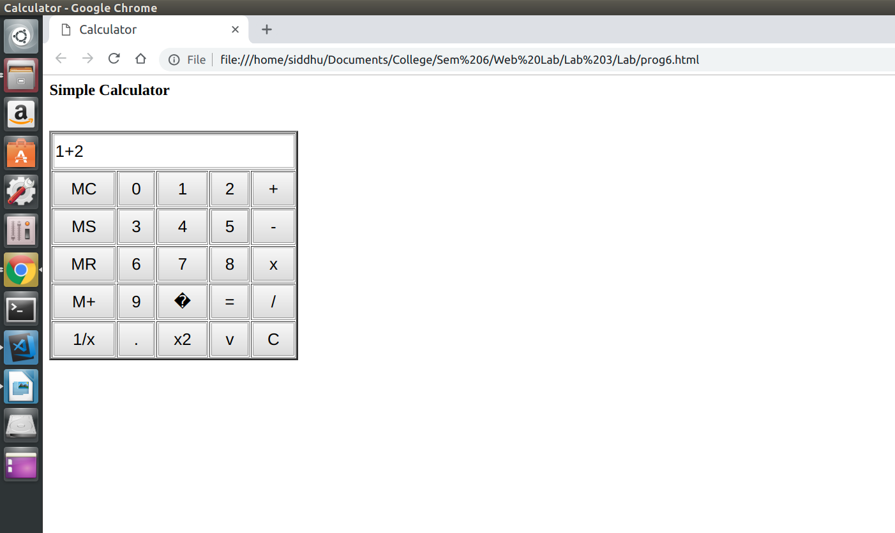
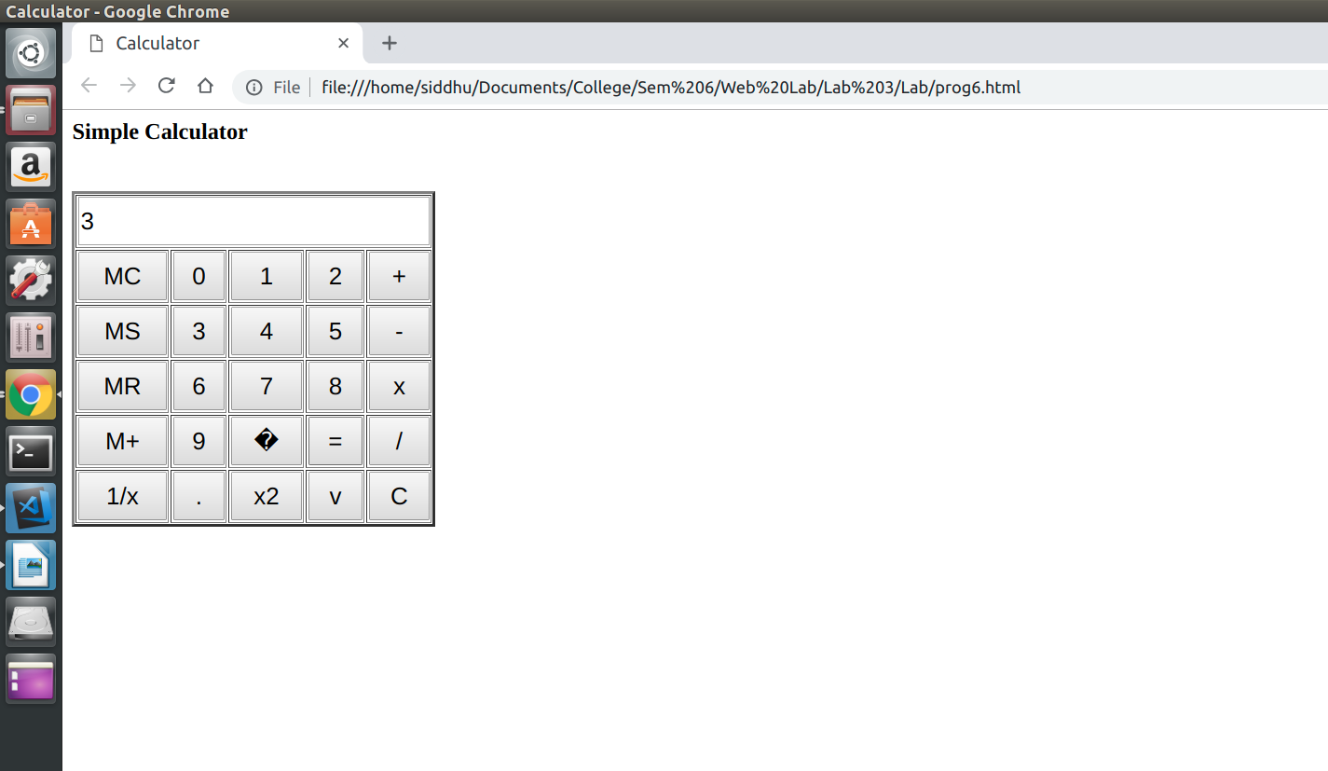

Result:
Thus the program is executed and output is obtained

Program – 7

AIM :
To design a webpage to display a digital clock in JavaScript.

PROGRAM :

prog7.html

<!DOCTYPE html>
<html>
<head>
<meta charset="utf-8" />
<meta http-equiv="X-UA-Compatible" content="IE=edge">
<title>Page Title</title>
<meta name="viewport" content="width=device-width, initial-scale=1">
<link rel="stylesheet" type="text/css" media="screen" href="main.css" />
<script src="main.js"></script>
</head>
<body onload="startTime()">
<div id="txt"></div>
</body>

<script>
function startTime() {
var today = new Date();
var h = today.getHours();
var m = today.getMinutes();
var s = today.getSeconds();
m = checkTime(m);
s = checkTime(s);
document.getElementById('txt').innerHTML = h + ":" + m + ":" + s;
var t = setTimeout(startTime,500);
}
function checkTime(i) {
if(i<10)
{
i = "0" + i;
}
return i;
}
</script>
</html>

OUTPUT :

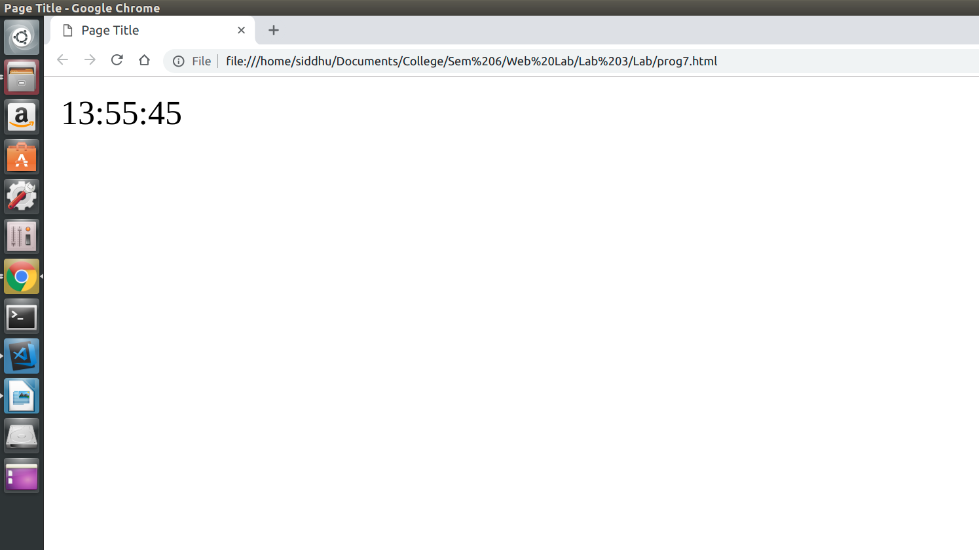

Result:
Thus the program is executed and output is obtained

Program – 8

AIM :
To create, test and validate an XHTML document that describes an ordered list of 5 movies.

PROGRAM :

prog8.html

<!DOCTYPE html
PUBLIC "-//W3C//DTD XHTML 1.0 Transitional//EN" "http://www.w3.org/TR/xhtml1/DTD/xhtml1-transitional.dtd">
<html xmlns="http://www.w3.org/1999/xhtml">

<head>
<title>
Movies List
</title>
</head>

<body>
<ol>
<li>Inception</li>
<li>The dark knight</li>
<li>La la land</li>
<li>The Avengers</li>
<li>Deadpool</li>
</ol>
</body>

</html>

OUTPUT :

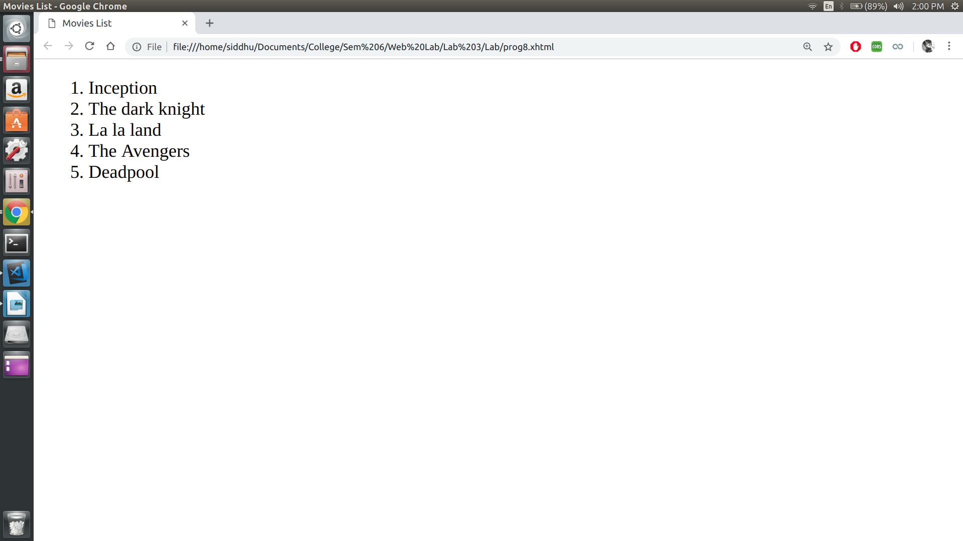

Result:
Thus the program is executed and output is obtained

Program – 9

AIM :
To create, test and validate an XHTML document that has a form with :
(i) A textbox to collect the user names.
(ii) Four check boxes.
(iii) A collection of 3 radio buttons

PROGRAM :

prog9.html

<!DOCTYPE html
PUBLIC "-//W3C//DTD XHTML 1.0 Transitional//EN" "http://www.w3.org/TR/xhtml1/DTD/xhtml1-transitional.dtd">
<html xmlns="http://www.w3.org/1999/xhtml">

<head>
<title>Document</title>
</head>

<body>
UserName: <input type="text" /> <br />
Strengths <br />
<form>
<input type="checkbox" name="gp2" id="cb1" /> Leadership<br />
<input type="checkbox" name="gp2" id="cb2" /> Technical<br />
<input type="checkbox" name="gp2" id="cb4" /> Marketing <br />
</form>
DEPARTMENT <br />
<form>
<input type="radio" name="gp1" id="rb1" checked="checked" />Computer Science Engineering<br />
<input type="radio" name="gp1" id="rb2" />Electronics and Communication Engineering<br />
<input type="radio" name="gp1" id="rb3" />Production Technology<br />
<input type="radio" name="gp1" id="rb4" />Rubber and Plastic Technology<br />
<input type="radio" name="gp1" id="rb5" />Mechanincal Engineering<br />
<input type="radio" name="gp1" id="rb6" />Automobile<br />
<input type="radio" name="gp1" id="rb7" />Aeronautical Engineering<br />
<input type="radio" name="gp1" id="rb8" />Elecronic and Instrumentation Engineering<br />
<input type="radio" name="gp1" id="rb9" />Information Technology<br />

</form>
</body>

</html>

OUTPUT :

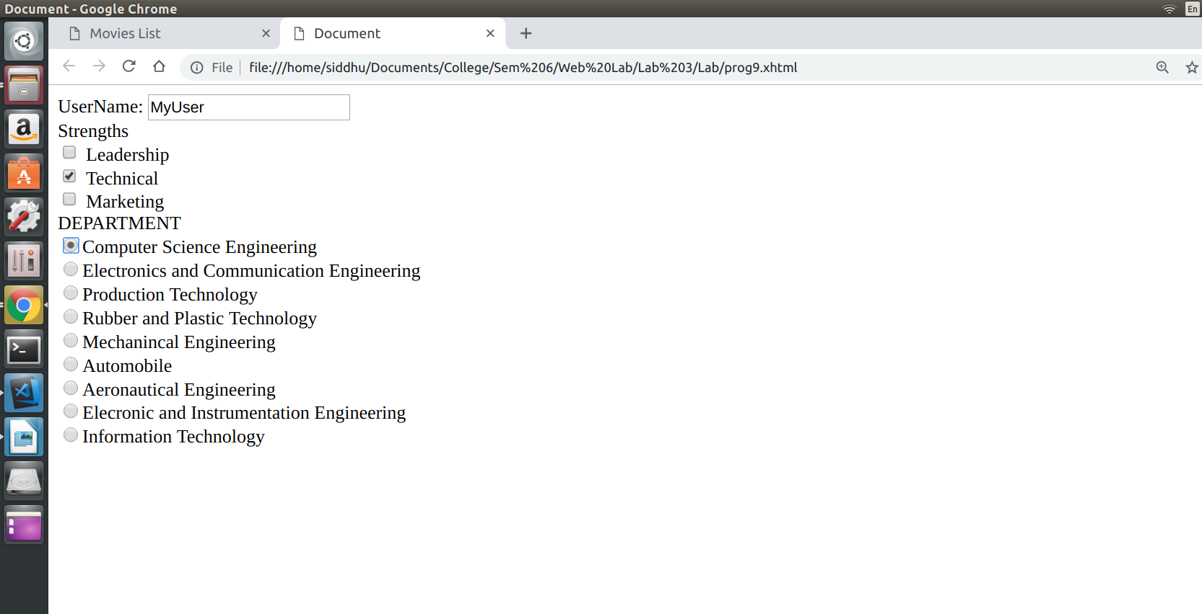

Result:
Thus the program is executed and output is obtained

Program – 10

AIM :
To create a dynamic website of Department of Computer Technology in HTML / XHTML / JavaScript/

PROGRAM :

index.html

<!DOCTYPE html PUBLIC "-//W3C//DTD XHTML 1.0 Transitional//EN" "http://www.w3.org/TR/xhtml1/DTD/xhtml1-transitional.dtd">
<html xmlns="http://www.w3.org/1999/xhtml">
_{<head>}
<meta http-equiv="Content-Type" content="text/html; charset=utf-8" />
<link rel="stylesheet" type="text/css" href="style.css" />
<title>Computer Technology</title>
_{</head>}

_{<body>}
_{<div id="container">}
_{<div id="mainpic">}
<h1 style="color:blue">Department of <span class="lightblue">Computer Technology</span></h1>
_{</div>}

_{<div id="menu">}
_{<ul>}
<li class="menuitem"><a href="#">Home</a></li>
<li class="menuitem"><a href="#">About</a></li>
<li class="menuitem"><a href="http://www.mitindia.edu/en/ct-faculty">Faculty List</a></li>
<li class="menuitem"><a href="http://www.ct.mitindia.edu/studentslist.html">Student List</a></li>
<li class="menuitem"><a href="#">Services</a></li>
<li class="menuitem"><a href="#">Contact</a></li>
_{</ul>}
_{</div>}
_{<div id="content">}
_{<p>&nbsp;</p>}
_{<p>&nbsp;</p>}
_{<h1>ABOUT US</h1>}
<p> Computer technology has become an integral part of our daily life. It is the most important element in the education of students of the present and the future era. Computer Technology has revolutionized society to a great extent. Technological advancements are so rapid in this field that continual learning is essential to keep the skill set of students up to date. The department of Computer Technology was recently established in MIT campus of Anna University by bifurcating the department of Information Technology. The department offers course in computer science and engineering at undergraduate & postgraduate levels and full time/part time research programs. The teaching and learning process emphasizes equally on theoretical and practical aspects catering to the needs of industries.</p>
_{<p>&nbsp;</p>}
_{<h2>Placement</h2>}
<p>The placement session that took place was highly successful and many students bagged great offers from various leading _{mncs</p>}
_{<p>&nbsp;</p>}
_{<h2>Contact US</h2>}
<p>Department of Computer Technology, <br />Madras Institute of Technology, <br />MIT Road, Radha Nagar, Chromepet,
<br />Chennai, Tamil Nadu 600044, India. <br />Tel:+91 44 _{2251 6231/32</p>}
_{<p>&nbsp;</p>}
_{<p>&nbsp;</p>}
_{<p>&nbsp;</p>}
_{<p>&nbsp;</p>}
_{<p>&nbsp;</p>}
_{<div id="footer">}
<h3><a href="http://www.bryantsmith.com">florida web _{design</a></h3>}
_{</div>}
_{</div>}
_{</div>}
_{</body>}
_{</html>}

style.css

body {
margin: 0;
padding: 0;
text-align: left;
font: 12px Arial, Helvetica, sans-serif;
font-size: 13px;
color: #061C37;
background: #1E4297;
background-repeat:repeat-x;
}
*
{
margin: 0 auto 0 auto;
text-align:left;}

#container
{
display: block;
height:auto;
position: relative;
width: 940px;
}
#mainpic h1
{
position:absolute;
text-align:right;
font-size:30px;
color:#FFF;
left:550px;
top:100px;
}
#mainpic h2
{
position:absolute;
text-align:right;
color:#E1E7F7;
left:550px;
top:130px;
}
#mainpic
{
background-image:url(images/main.jpg);
background-repeat:no-repeat;
width:900px;
height:402px;
}
.lightblue
{
color:black;
}
#menu
{
background-image:url(images/menu.png);
background-repeat:no-repeat;
width:940px;
height:69px;
float:left;
clear:both;
}
#content
{
width:880px;
height:auto;
background-color:#FFF;
padding-left:10px;
padding-right:10px;
padding-bottom:5px;
}
#footer
{
width:inherit;
height:auto;
}
#footer h3 a,#footer h3 a:visited
{
display:inline;
text-align:center;
font-size:12px;
text-decoration:none;
color:#7198E1;
}
#menu ul {
list-style: none;
padding: 0px;
margin-left:auto;
width:900px;
}
#menu li {
list-style: none;
padding: 0px;
display: inline;
}
#menu a {
float: left;
width: 150px;
height: 40px;
display: block;
text-align: center;
text-decoration: none;
color: #ffffff;
font-weight: bold;
padding-top: 17px;
font-size: 15px;
}
html, body {
text-align: center;
}
p {text-align: left;}

OUTPUT :
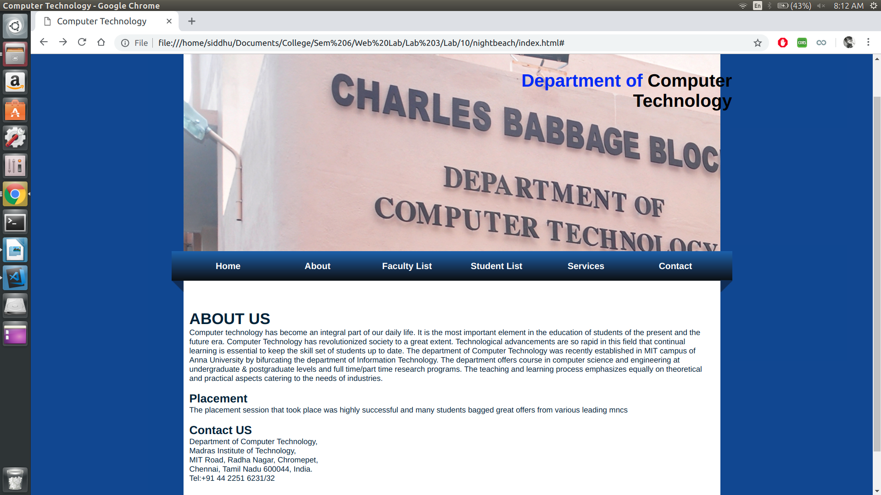
Result:
Thus the program is executed and output is obtained

